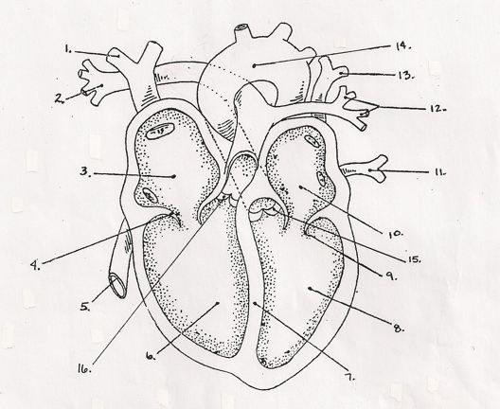
Name:_____________________________

- Label the heart
- Use blue arrows to show the flow of deoxygenated blood through the heart
- Use red arrows to show the flow of oxygenated blood through the heart
- Where did the blood come from that is entering the following?
  - 1
  - 5
  - 13
  - 14
- Where is the blood going when it leaves the following?
  - 2
  - 12
  - 14

